*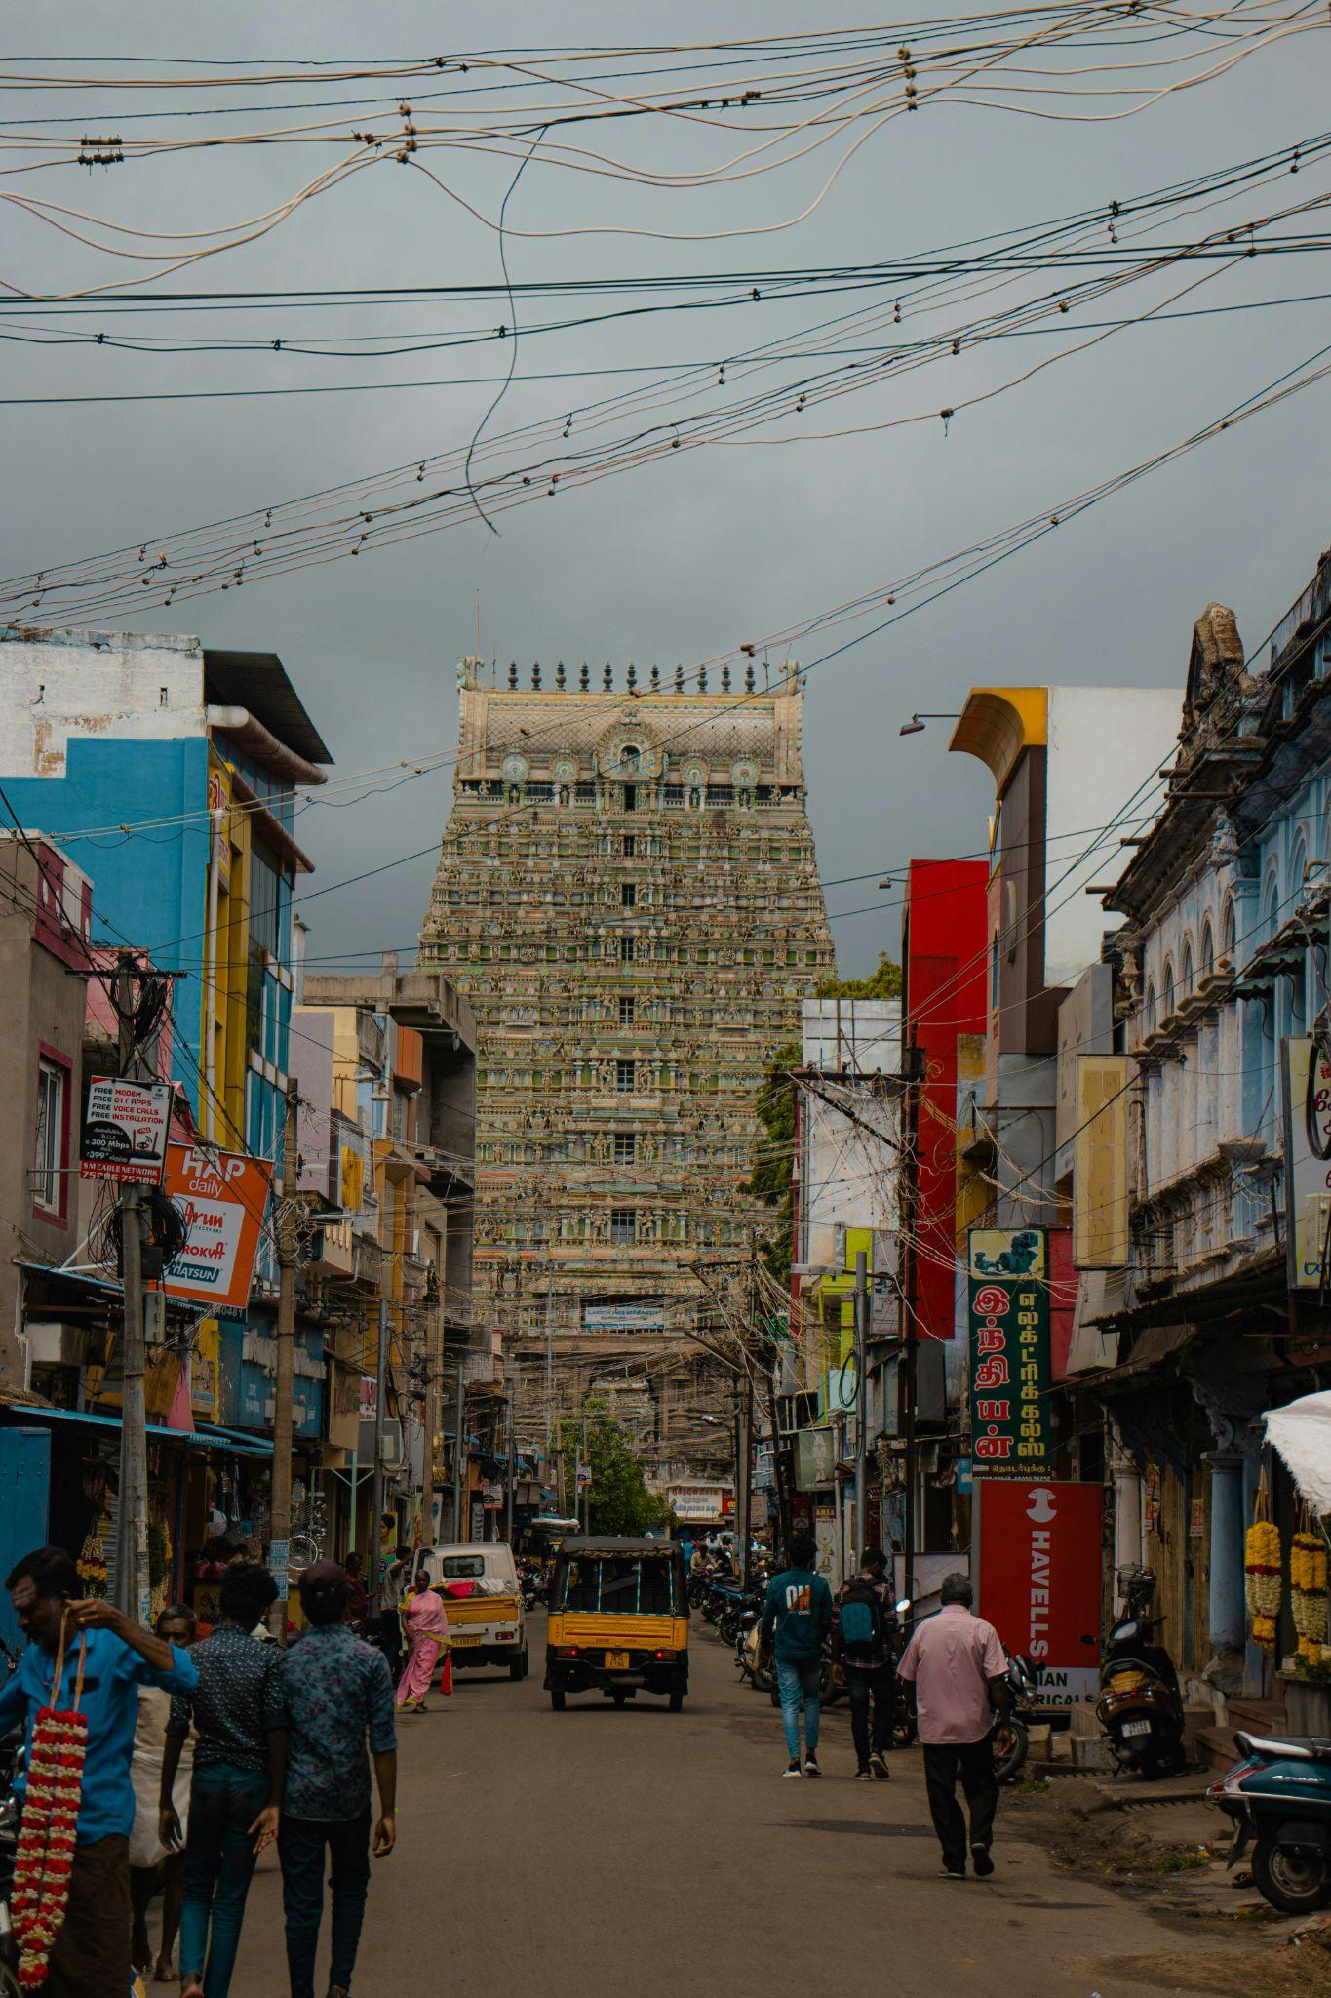* TENKASI - *Exploring the Enchanting Charms of Tenkasi: A Hidden Gem in Tamil Nadu*

*Nestled amidst the lush greenery of Tamil Nadu, Tenkasi stands as a testament to the state's rich cultural heritage and natural beauty. Often overshadowed by its more renowned counterparts, this quaint town holds a treasure trove of surprises waiting to be discovered by travelers seeking authenticity and tranquility. Join me on a virtual journey as we unravel the enchanting charms of Tenkasi.*

A Glimpse into History -

*Tenkasi, also known as the "Kashi of the South" due to its numerous temples and religious significance, boasts a history that dates back several centuries. Its name is derived from the words "ten," meaning South, and "kasi," referring to the holy city of Varanasi. This cultural blend is evident in the town's architecture, cuisine, and traditions.*

Architectural Marvels -

*The town is adorned with magnificent temples that showcase exquisite Dravidian architecture, offering a glimpse into the region's religious fervor and artistic prowess. The most prominent among them is the Kasi Viswanathar Temple, dedicated to Lord Shiva, which exudes grandeur with its towering gopurams (entrance towers) adorned with intricate sculptures and carvings.*

Natural Splendor -

*Tenkasi is blessed with abundant natural beauty, making it a paradise for nature lovers. The crown jewel of its scenic attractions is the breathtaking Coutrallam Falls, also known as the Spa of South India. Surrounded by dense forests and lush greenery, the cascading waters of Coutrallam create a serene ambiance that rejuvenates the mind and soul.*

Cultural Tapestry -

*The vibrant culture of Tenkasi is reflected in its festivals, folk dances, and music. The town comes alive during festivals like Mahamaham and Thai Pusam, where devotees from far and wide gather to celebrate with fervent devotion and colorful processions. Traditional art forms like Bharatanatyam, Koothu, and Karakattam add to the cultural tapestry of the region, captivating audiences with their grace and dynamism.*

Culinary Delights -

*No exploration of Tenkasi is complete without indulging in its delectable cuisine. From piping hot idlis and dosas served with spicy chutneys to flavorful biryanis and mouthwatering desserts like jaggery-based sweets, every dish is a culinary delight that tantalizes the taste buds and leaves a lasting impression.*

Hospitality and Warmth -

*What truly sets Tenkasi apart is the warmth and hospitality of its people. Known for their simplicity and generosity, the locals welcome visitors with open arms, eager to share their stories and traditions. Whether savoring a home-cooked meal with a local family or exploring the town's hidden gems with a knowledgeable guide, every experience in Tenkasi is infused with warmth and authenticity.*

Conclusion -

*In a world that often prioritizes popular tourist destinations, Tenkasi remains a well-kept secret waiting to be uncovered. With its rich history, architectural marvels, natural splendor, vibrant culture, and delectable cuisine, this hidden gem offers a truly immersive travel experience that leaves a lasting impression on all who visit. So, if you're seeking a retreat from the hustle and bustle of city life, pack your bags and embark on a journey to the enchanting town of Tenkasi. You won't be disappointed.*